C. Yet Another Counting Problem
time limit per test
3.5 seconds
memory limit per test
256 megabytes
input
standard input
output
standard output
You are given two integers aa and bb, and qq queries. The ii-th query consists of two numbers lili and riri, and the answer to it is the number of integers xx such that li≤x≤rili≤x≤ri, and ((xmoda)modb)≠((xmodb)moda)((xmoda)modb)≠((xmodb)moda). Calculate the answer for each query.
Recall that ymodzymodz is the remainder of the division of yy by zz. For example, 5mod3=25mod3=2, 7mod8=77mod8=7, 9mod4=19mod4=1, 9mod9=09mod9=0.
Input
The first line contains one integer tt (1≤t≤1001≤t≤100) — the number of test cases. Then the test cases follow.
The first line of each test case contains three integers aa, bb and qq (1≤a,b≤2001≤a,b≤200; 1≤q≤5001≤q≤500).
Then qq lines follow, each containing two integers lili and riri (1≤li≤ri≤10181≤li≤ri≤1018) for the corresponding query.
Output
For each test case, print qq integers — the answers to the queries of this test case in the order they appear.
Example
input
Copy
2
4 6 5
1 1
1 3
1 5
1 7
1 9
7 10 2
7 8
100 200
output
Copy
0 0 0 2 4
0 91

是真的sb啊。。。你居然都不考虑 l前面的lcm辐射到l上的长度。。
唉。。活该你sb

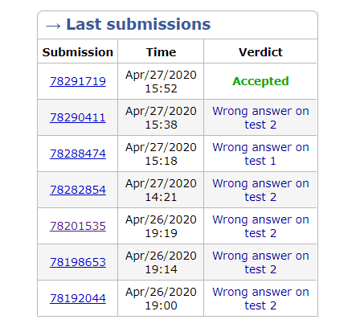快乐吗？
#include<bits/stdc++.h>
#define ll long long
using namespace std;
ll gcd(ll x,ll y)
{
if(y==0) return x;

else gcd(y,x%y);
}
ll ans[600];
int main()
{
int t;
scanf("%d",&t);
while(t--)
{
ll a,b,q;

scanf("%lld %lld %lld",&a,&b,&q);

ll g=gcd(a,b);

ll mb=a*b/g;
for(int i=0;i<=q;i++) ans[i]=0;
//cout<<mb<<endl;

for(int kkk=1;kkk<=q;kkk++)
{
ll l,r;
scanf("%lld %lld",&l,&r);
ans[kkk]=r-max(max(a,b),l)+1;
if(ans[kkk]<0) ans[kkk]=0;
l=max(max(a,b),l);
ll hehe1=l/mb;
ll hehe2=mb*hehe1;
ll ct1=hehe1;
if(hehe2<l) {ct1++;if((hehe2+max(a,b)-1)>=l&&ct1!=1) {ll fk=min(hehe2+max(a,b)-1-l+1,r-l+1);if(ans[kkk]-fk>=0&&fk>0){ans[kkk]-=fk;}}}
hehe1=r/mb;
hehe2=mb*hehe1;
ll ct2=hehe1;
//if(hehe2<r) { ct2++;}
if(mb*ct1>=l&&mb*ct1<=r) ans[kkk]-=min(r-mb*ct1+1,max(a,b));
if(ct2>ct1) { if(mb*ct2>=l&&mb*ct2<=r) ans[kkk]-=min(r-mb*ct2+1,max(a,b));}
if(ct2-ct1-1>0) ans[kkk]-=(ct2-ct1-1)*max(a,b);

}
//if(g==a||g==b) {for(int i=1;i<=q;i++) printf("0 ");}
for(int i=1;i<=q;i++) printf("%lld ",ans[i]);
printf("\n");
}
return 0;
}

